Program Salt & Smooth

Statslibrary2

Laiba S Khan

2023

Table of Contents

Plot, Salt, Smooth 2

The Function 2

Program Plotter 2

Salter 3

Smoother 3

Maven 3

Matlab Octave 3

Report 9

# Plot, Salt, Smooth

## The Function

The function that was chosen for this assignment was . This equation was chosen due to the way the graph appears, and its higher challenge to implement. The function includes both the eulers number, an exponent, and sin(x).

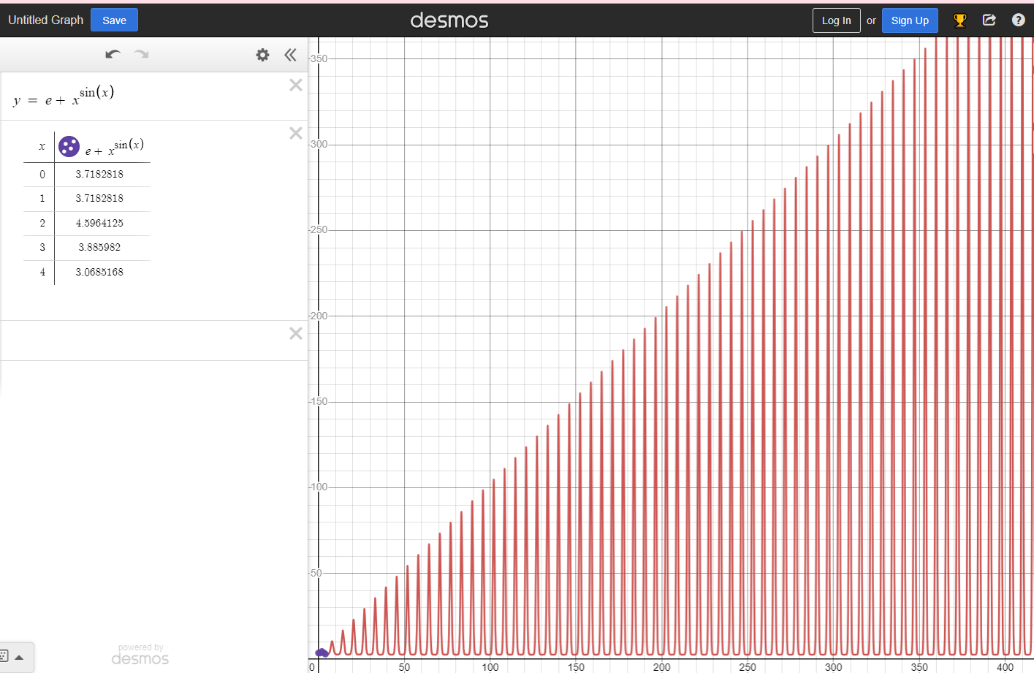

## Program Plotter

# ProgramPlotter.java was implemented with two methods, one for writing results into a CSV file, and one that calculated the function results. The method ResultsinRange method is as shown below.

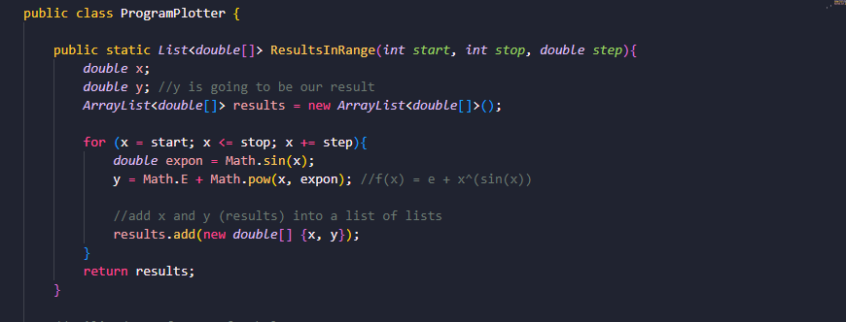

The ResultsinRange method takes the parameters for when you want the x-value to start, stop, and the increments of it as well. It takes each input, calculates the result (which is the corresponding y-value), and adds it to a new ArrayList called results. It returns the list, allowing the CSVWriter to use the list and write a CSV file with your choice of file name.

## Salter

## Smoother

# Maven

# Matlab Octave

Program Used:

MatLab

Tutorial Used:

<https://www.mathworks.com/help/matlab/ref/plot.html>

https://www.youtube.com/watch?v=aD8k4pYUBOk

# Report

JfreeChart and Apache:

<https://commons.apache.org/proper/commons-math/userguide/stat.html>

Using the StatUtils utility class:

1.2

// Compute statistics directly from the array

// assume values is a double[] array

double mean = StatUtils.mean(values);

double std = FastMath.sqrt(StatUtils.variance(values));

double median = StatUtils.percentile(values, 50);

// Compute the mean of the first three values in the array

mean = StatUtils.mean(values, 0, 3);

You can use this to do the smoothing

Or when using Mav select Create Maven Project after downloading maven extension (if you don’t already have it)

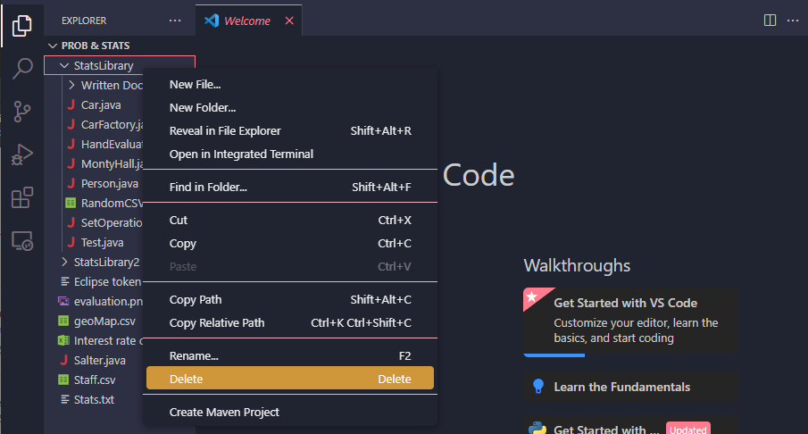

After right clicking maven project and selecting custom command

